PERSONAL PROFILE

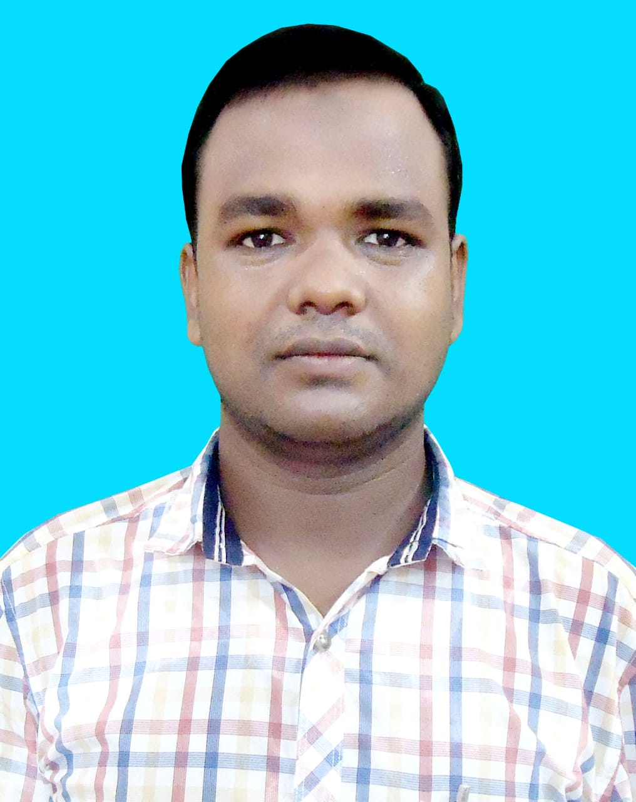
Recent Photograph

Name:-MD AJIJUR RAHAMAN

Designation:- ASSISTANT PROFESSOR

Date of Birth:- 06.08.1984

Educational Qualification:-
Sl No. | Degree obtain  (Abbreviation of the degree) | College/ university from which the degree was obtained | Year of Passing
1 | MP | WBBSE | 1999
2 | HS | WBCHSE | 2001
3 | B.A HONS (HISTORY) | NBU | 2004
4 | M.A (HISTORY) | NBU | 2006

Permanent Address:- VILL: MILANPARA KAHATA, PO&PS: CHAKULIA,

DIST: UTTARDINAJPUR, WEST BENGAL, 733208

Contact Number:- 9734930097

E-mail:-mdajijur.rahaman9@gmail.com

Date of joining(Service):- 09.08.1984

Specialization:- Medieval India

Area of Interest:-

Faculty Development Programme:-
Sl No. | Year | Name of Programme Participated (OP/ RC/FDP/Summer School/FEP/Others) | Organized By
1 | 2021 | FACUTY INDUCTION PROGRAMME | NBU
2 | 2022 | REFRESHER COURSE | NBU

Research Journal Publication (National and International) :-

National/Regional/ State Level:-
Sl No. | Year of Publication | TITLE | Journal Name | ISSN/ ISBN | Published By
1 | 2023 | PHYSICAL FEATURES AND SETTLEMENT PATTERNS OF COOCHBEHAR | IJHESM | 2582-8169

Paper Presentation: Conferences/Seminars /Symposia /Workshops:-
Sl no. | Year | Title | Organized by | International  /National  / State Level
1 | 2023 | PHYSICAL FEATURES AND SETTLEMENT OF COOCHBEHAR | MURSHIDABAD ADARSHA MAHAVIDYALAYA | NATIONAL

